*Greyden Scott*

*N9935924*

*CAB432 – Cloud Computing*

Assignment 01 – Mashup Project Report

Table of Contents

Introduction 3

News API 3

IBM Watson Tone Analyzer 3

Google Charts 3

Use Cases 4

Use Case A 4

Use Case B 5

Use Case C 6

Technical Breakdown 7

Client 7

Server 8

Response Filtering 8

Docker 8

PUG 9

Difficulties 10

Filtering Responses 10

Extensions 11

Cloud Vision 11

More News Sources 11

Advance Search 11

Testing 12

Cases 12

Appendix A – User Guide 14

Appendix B – Test Case Screenshots 16

# Introduction

BuzzTone aims to provide users with a visual representation of the descriptions of news articles from the Buzzfeed Website. Utilising the News API, IBM Watson Tone Analyzer and Google Charts, users can search for Buzzfeed news articles on a topic of their choosing and be presented with graphed information relating to the emotional tone of the article. BuzzTone has been developed with ease of use in mind.

When the users calls the page they are presented automatically with Buzzfeeds top news headlines with tone analysis performed, users can then perform a simple search to query for article subjects and the results are displayed in a tile card format.

## News API

<https://newsapi.org>

News API is a well document API that returns JSON metadata for news headlines and articles from all over the web. News API has access to over 30,000 news sources and blogs. However, for the purposes of BuzzTone, information is only obtained from the Buzzfeed news website.

BuzzTone utilises only two API endpoint provided by News API; *newsapi.v2.everything,* which is used to search for news headlines, a URL linking to the original article, an image URL related to the article and the description of the article. The other end point is *newsapi.v2.topHeadlines,* which is used for retrieving the same details, however it does not take query and instead returns the News API top headlines for the specified source news website.

## IBM Watson Tone Analyzer

<https://www.ibm.com/watson/services/tone-analyzer/>

The IBM Watson Tone Analyzer API is one of IBM Watsons machine learning API’s which can be used to analyse emotions and tones in written text. Tone Analyzer breaks down the text inputted, providing the tones it detects and a score for each tone.

BuzzTone uses Tone Analyzer to analyse the Buzzfeed news article descriptions for tones to predict the emotional disposition of a news article.

## Google Charts

<https://developers.google.com/chart/>

Google Charts is a JavaScript API that allows structured data to be displayed in a visual diagram. The API is well documented and easily allows for the creation of interactive diagram charts.

The Google Charts library is included within the client-side index and is obtain via CDN. The diagrams are initialised and displayed when the web page has completed loading.

# Use Cases

## Use Case A

**As a Buzzfeed reader I want to search for articles on a subject and see the overall emotional tone so that I can see a visual representation of all article tones.**

The user navigates to the index page of BuzzTone, with the intent to search for a specific subject of articles. They are presented with a search field and search button. The user can enter any text into the search field and either hit “Enter” on their keyboard, or the click the “Search” button.

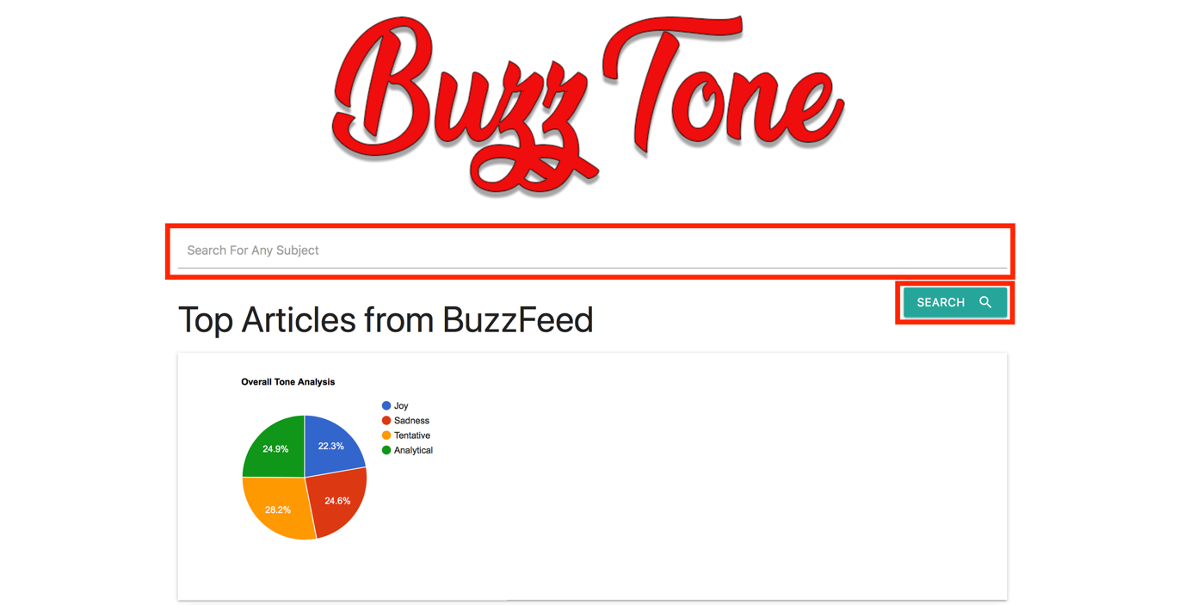

The user is then presented with the results, with the overall Tone Analysis showing at the top of the page.

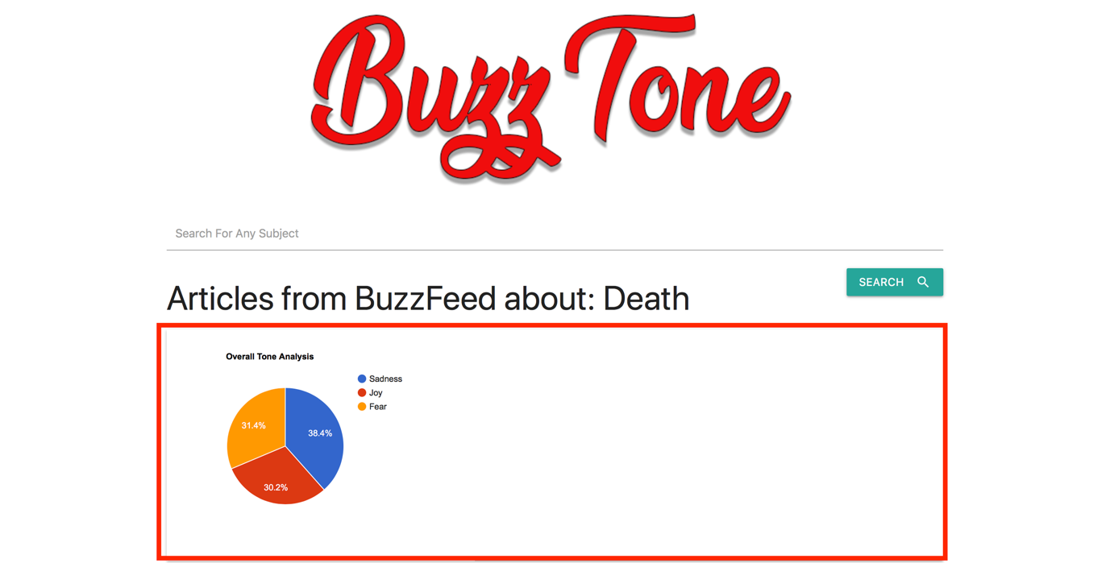

## Use Case B

**As a Buzzfeed reader I want to search for articles on a subject and see the tone for each article so that I can see a visual representation of the specific article tones.**

After performing a search, the results are displayed on the page, scrolling further down will reveal the individual articles returned by the News API with a summary of the article information and bar chart which is handled by the Google Charts API, displaying the specific article tones which have been returned by the IBM Watson Tone Analyzer API.

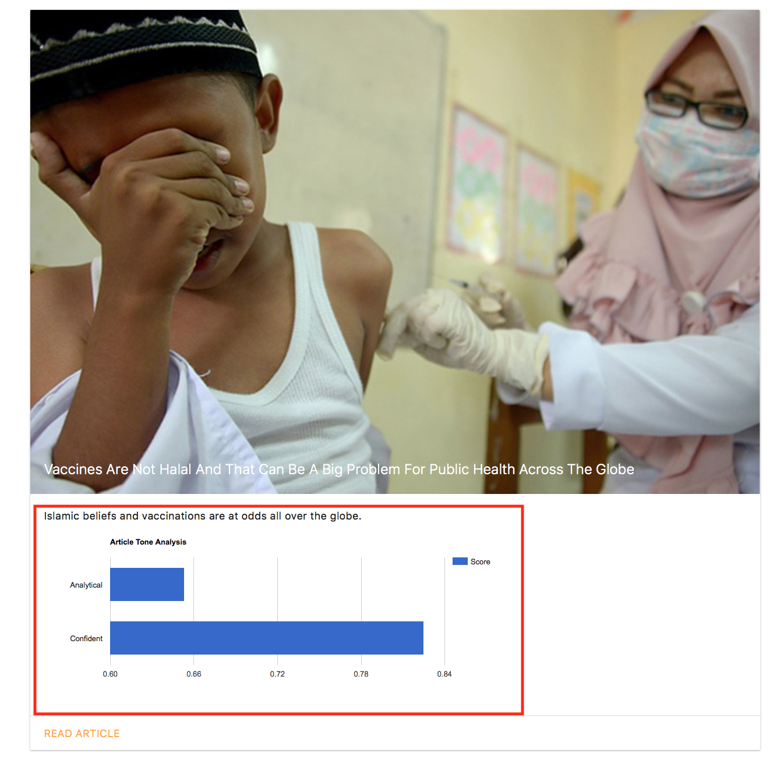

## Use Case C

**As a Buzzfeed reader I want to search for articles and view a listed view of all articles returned, the title, accompanying image and description.**

When the user searches for a subject the results are displayed on the page, by scrolling down the page the use will be presented with each article, an image, the title and description. The user also has the option of clicking “Read Article”, which will navigate them away from the site to the original source of the article.

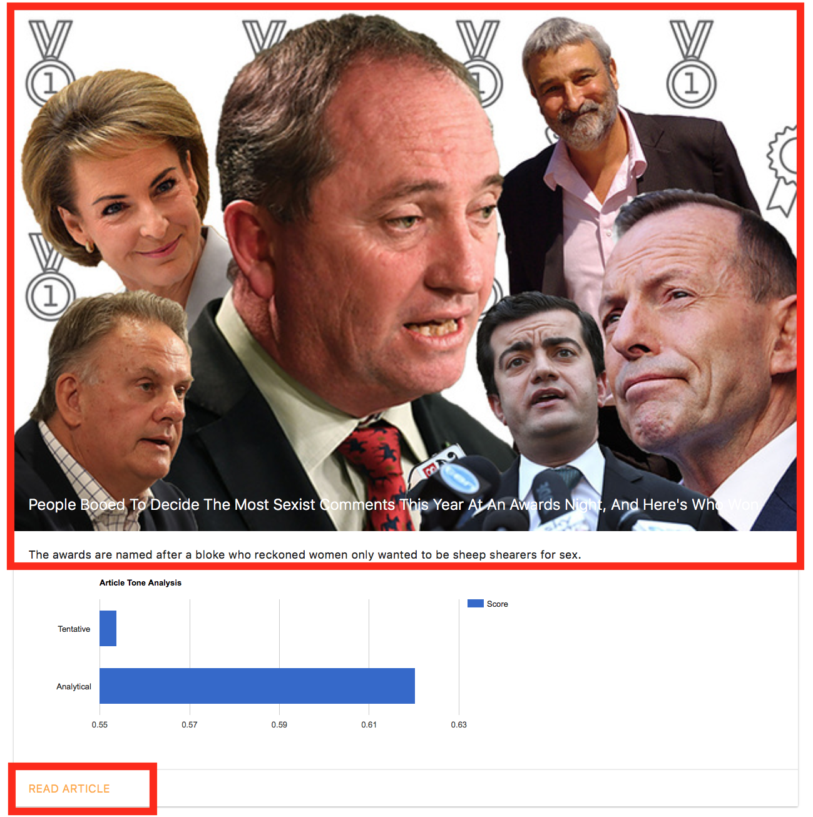

# Technical Breakdown

BuzzTone was designed to keep client-side processing to a minimum, this was done by ensuring all heavy processing was completed on the server side, with responses being optimised and filtered before being sent back to the client.

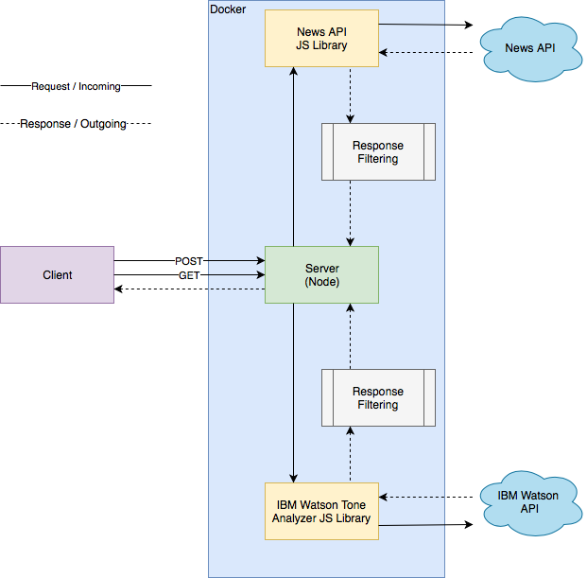

BuzzTone was developed in stages to ensure minimal data was being captured and provided to the client. The first stage involved processing the news articles and have them render on the client side. The second stage involved processing the article descriptions and retrieving tone analysis. The next stage involved displaying the results from the tone analysis into relevant Google chart. By developing the application in stages I was able to minimise development time and prioritise key components and abandon any non-necessary functionally. The application was also developed using Node Express Generator to quickly create an application skeleton. This also expeditated development and allowed me to focus more on the server-side API processing.

# Client

The client initiates two types of requests, initially a GET request which is sent to the server, the server then in turn serves an index page back to the client. The search request is a POST request which is initiated by the user when the user completes a search on the initially returned index page. The POST request is sent to the server in the body of the request message.

The server then handles the information sent from the POST request, the requested information is processed by the server and displayed, providing a Pie Chart of the overall emotional tone of all the articles retrieved, and individual cards displaying information about the articles and a Bar Graph displaying the results for the specific article.

## Server

The Node Server deals with routing incoming client requests and outgoing responses, when a GET request is received from the client, the server deals with the request by calling two external API’s. The first being the News API, which returns a JSON response to the server with Article objects. The server filters these objects and stores the filtered information temporarily in an array of newly created objects with only the relevant information present. This information is then passed to the IBM Watson Tone Analyzer API where the tones for each object are appended to the previously created objects as new object parameters. This information is then forwarded to the renderer to be displayed.

When a POST request is made similar server functionality is performed, the key difference being that the information sent to the server via the POST request is added to the News API to query the API with a specific subject matter that the user has specified. The response from the News API is still processed and passed to the IBM Watson Tone Analyzer API and then forwarded to the rendered to be displayed.

## Response Filtering

The News API and IBM Watson Tone Analyzer JS libraries handle the calls to the respective API’s and send the response back to the server. Both respond with JSON information, this information is further refined when received to minimise the payload being sent back to the client. This also allows for the information that is being handled on the server side to be simplified. Each News API article that is returned is created into an object, where only the necessary information to be stored on the client side is stored.

These objects are then stored in an array and passed to a function that calls IBM Watson Tone Analyzer API. Prior to passing the information through the API, the descriptions are filtered for any characteristics that would cause analysis problems and packaged together to be sent to the IBM Watson Tone Analyzer API for analysis as one payload.

The returned response from IBM Watson Tone Analyzer is then filtered for only the necessary information being displayed and appended to the Article Object as new parameters.

## Docker

Docker has been used to encapsulate the BuzzTone application and include the node server, JavaScript libraries and front-end PUG templates.

The build has been derived from the official Docker Node image, using the Node 8 image, carbon.



The first line of the docker file sets node:carbon as the parent image as previously mentioned, this image contains the necessary dependencies to run the BuzzTone application. The maintainer is listed as myself. On the next line we add the /App directory, then port 3000 is exposed for the Node server. We then set the working directory to inside the BuzzTone folder, this then allows us to change the environment to production. Then npm is run to ensure dependent node packages are installed and that the packages are in the docker image. The last line then starts the application.

## PUG

PUG has been used to manage the frontend templates for BuzzTone, it is used on the server-side to render the index page. Three pug files are utilised, the first is *layout.pug* which holds the header that contains links to the CSS, JavaScript for some additional CSS functionality and gstatic charts loader. The second file is the index which renders the main page content. When the server renders the index page it attaches the *index.pug* to the *layout.pug*. The third file is another extension of the *layout.pug* called *error.pug* which is used to render potential errors that may occur. Again, this is called through the layout.pug, which ensure that the user can re-run searches in the event they fail.

# Difficulties

## Filtering Responses

Initially BuzzTone was to be a service that presented news headlines from numerous news sources, this proved to be a significant challenged for the IBM Watson Tone Analyzer to process. IBM Watson Tone Analyzer API would not necessarily return a tone for every item sent to its API. News headlines tended to be too short, lacking proper grammar to have analysis performed on them or just down right trivial and un-interpretable.

To combat this, I first attempted to limit the sources of news headlines. However, this had very limited effect, for every 20 headlines sent to IBM Watson Tone Analyzer, only 5 would come back with proper Tone Analysis. Instead I pivoted the design to instead look at the News Article Descriptions.

This presented further challenges, as either too much information was being sent to the API or too many API calls were being made (nearing me towards maxing my monthly API call limit). The solution to this problem was to filter and clean the information before it was being sent to the IBM Watson Tone Analyzer. Buzzfeed article descriptions were all appended with a “View entire article” text, which was unnecessary to process the tone of. Some descriptions also contained special characters which also confused the Tone Analyzer.

By filtering the data being sent to the IBM Watson Tone Analyzer the volume of descriptions being analysed incorrectly drastically decreased.

# Extensions

## Cloud Vision

It was a consideration to utilise either Google Cloud vision or IBM Visual Recognition to run analysis on the images returned by the news sources related to the individual articles. However, it was excluded so that more time could be focused towards the Tone Analysis functionality. A form of image recognition would allow users to get further information on the overall tone of the article as accompany imager can also be used to reflect the disposition and emotion in an article.

## More News Sources

The initial design proposed using a wider range of news sources, allowing the user to see a broader selection of news articles on the particular subject searched for from a variety of sources. This functionality was abandoned due to time constraints, as filtering the responses from News API would require a significantly more complex approach to ensure the information provided to the IBM Watson Tone Analyzer produced consistent and accurate results. Including this extension would provide the user with a wider variety of news sources to compare the tones. This could then be extended further to show the difference in tone from one news outlet to another.

## Advance Search

It was initially proposed that users would be able to perform a more complex search, allowing the user to choose how the data would be sorted (relevance or popularity), choose which news sources to obtain articles from and how the data should be represented (different types of graphs). However, this functionality was not implemented due to time constraints. Allowing this functionality would provide the user greater control of the information they search for and how it is displayed.

# Testing

Error handling was managed by promises within asynchronous functions. Specifically, the methods for retrieving articles and tones were created as asynchronous and use a Promise to resolve or reject the response depending on the outcome (Snippet A). This functions response is then handled by the router when processing a request by the client (Snippet B) and displays and error page PUG template to the client with error message that the user can interpret. As errors were originally coming back with text that was typically hard to interpret, I wrote simplified messages that would alert the user with a clear error message when an error response occurred.

#### Snippet A



#### Snippet B



## Cases

|  |  |  |  |
| --- | --- | --- | --- |
| Task | Expected Outcome | Result | Screenshot/s (Appendix B) |
| Retrieve Top Articles | Top Articles Displayed at top of page |  | 01 – A |
| Overall Tone Analysis Displays | PASS | 01 – B |
| Article Image Displays | PASS | 02 – A |
| Headline Displays | PASS | 02 – B |
| Individual Article Tone Analysis Displays | PASS | 02 – C |
| Article Description Displays | PASS | 02 – D |
| Link to article redirects correctly | PASS | 03 |
| Search Articles | Queried Text at top of page | Pass | 04 – A |
| Overall Tone Analysis Displays | PASS | 04 – B |
| Article Image Displays | PASS | 05 – A |
| Headline Displays | PASS | 05 – B |
| Individual Article Tone Analysis Displays | PASS | 05 – C |
| Article Description Displays | PASS | 05 – D |
| Link to article redirects correctly | PASS | 06 |
| Handle News API response error | Display error, application continues | PASS | 07 |
| Handle Tone Analyzer Error | Display error, application continues | PASS | 08 |

# Appendix A – User Guide

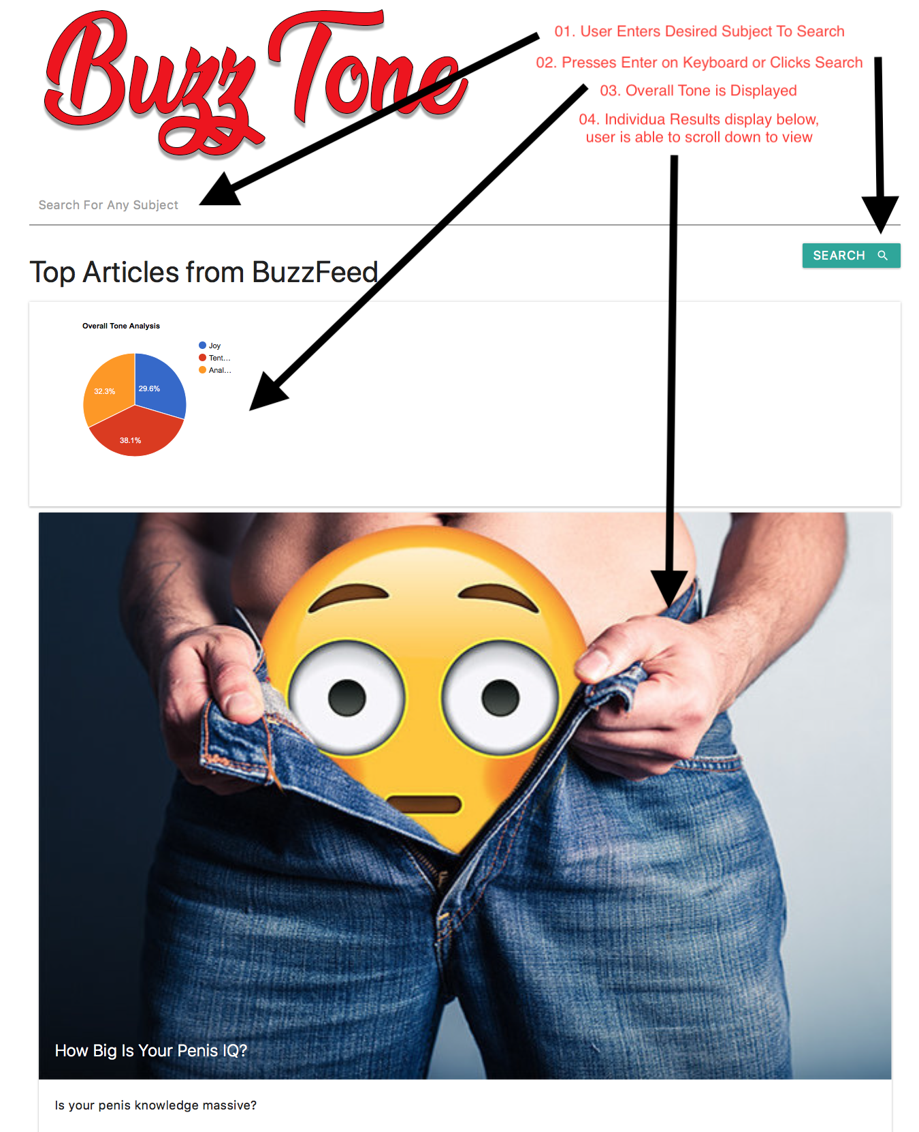

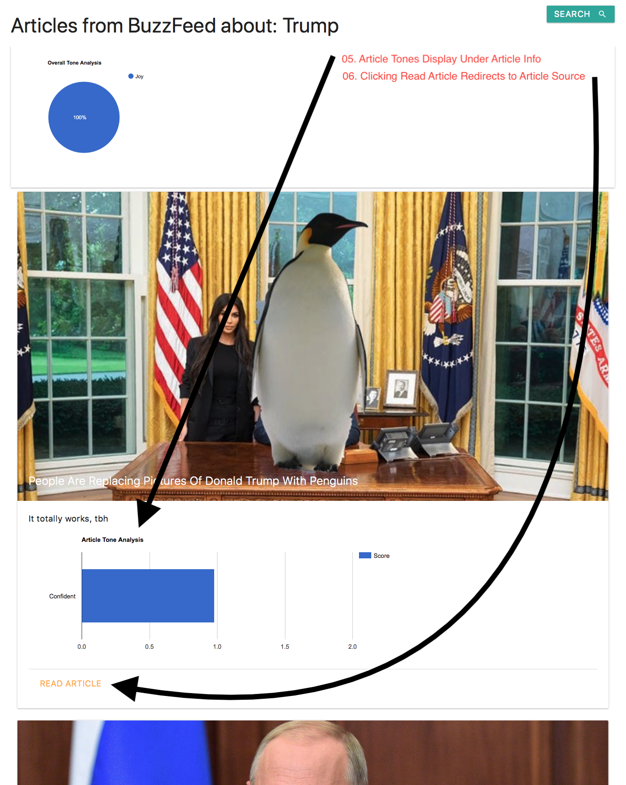

# Appendix B – Test Case Screenshots

01: A - Top Articles Displayed at top of page

01: B - Overall Tone Analysis Displays

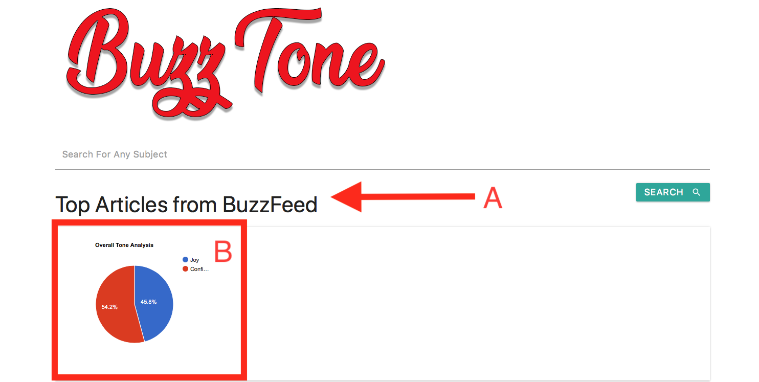

02: A - Article Image Displays

02: B - Headline Displays

02: C - Individual Article Tone Analysis Displays

02: D - Article Description Displays

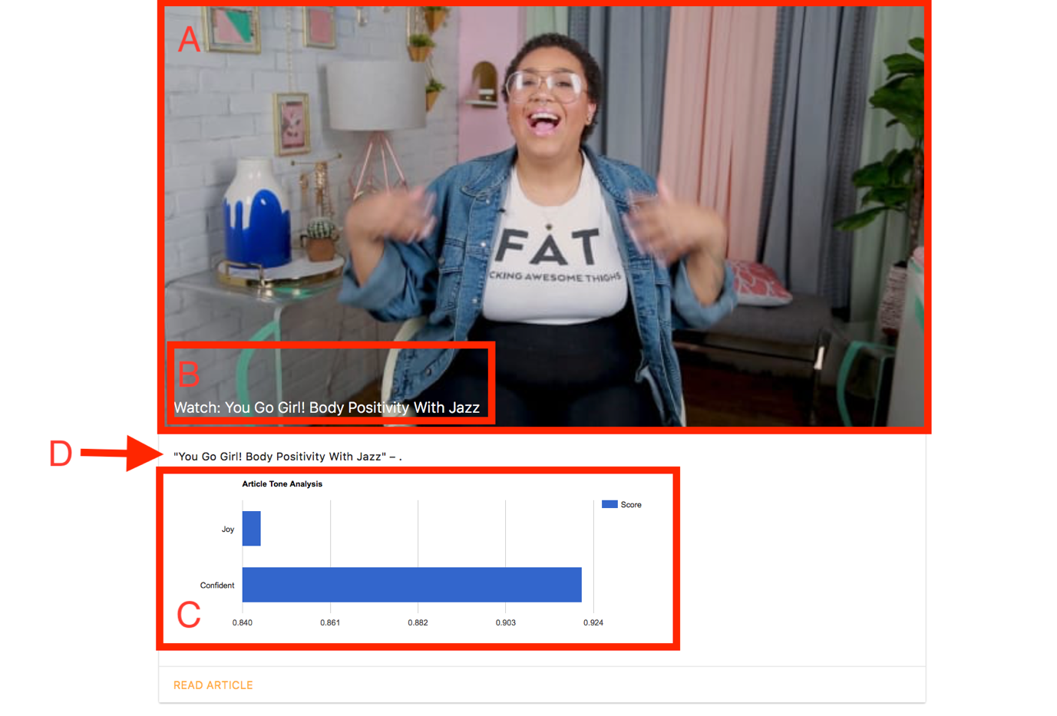

03: Link to article redirects correctly

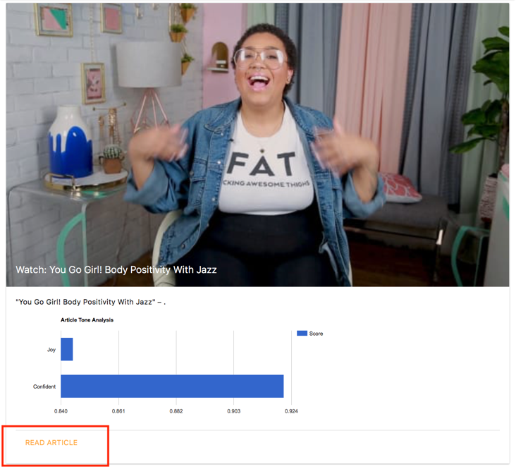

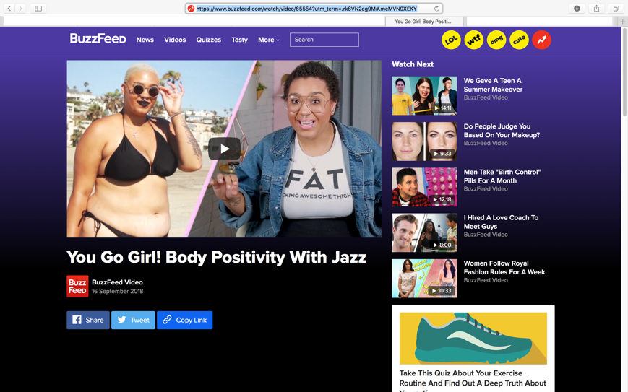



04: A - Queried Text at top of page

04: B - Overall Tone Analysis Displays

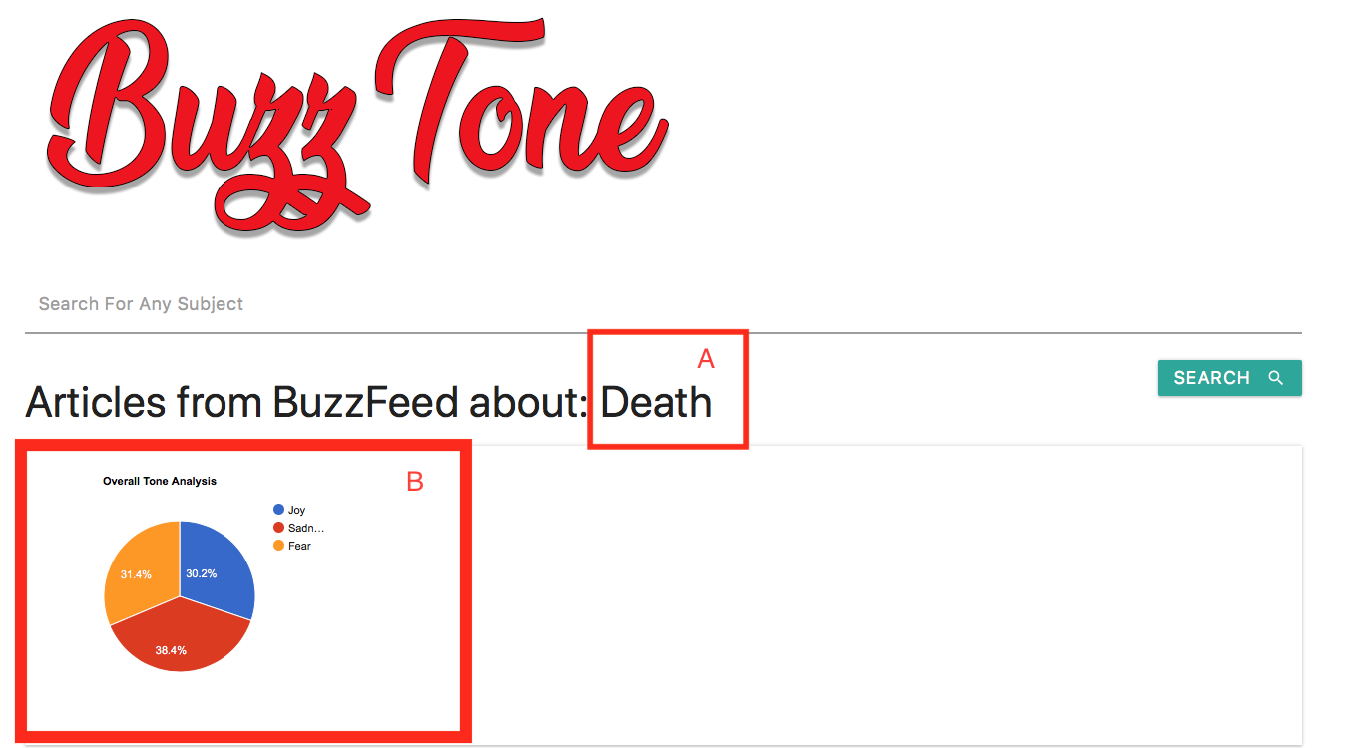

05: A - Article Image Displays

05: B - Headline Displays

05: C - Individual Article Tone Analysis Displays

05: D - Article Description Displays

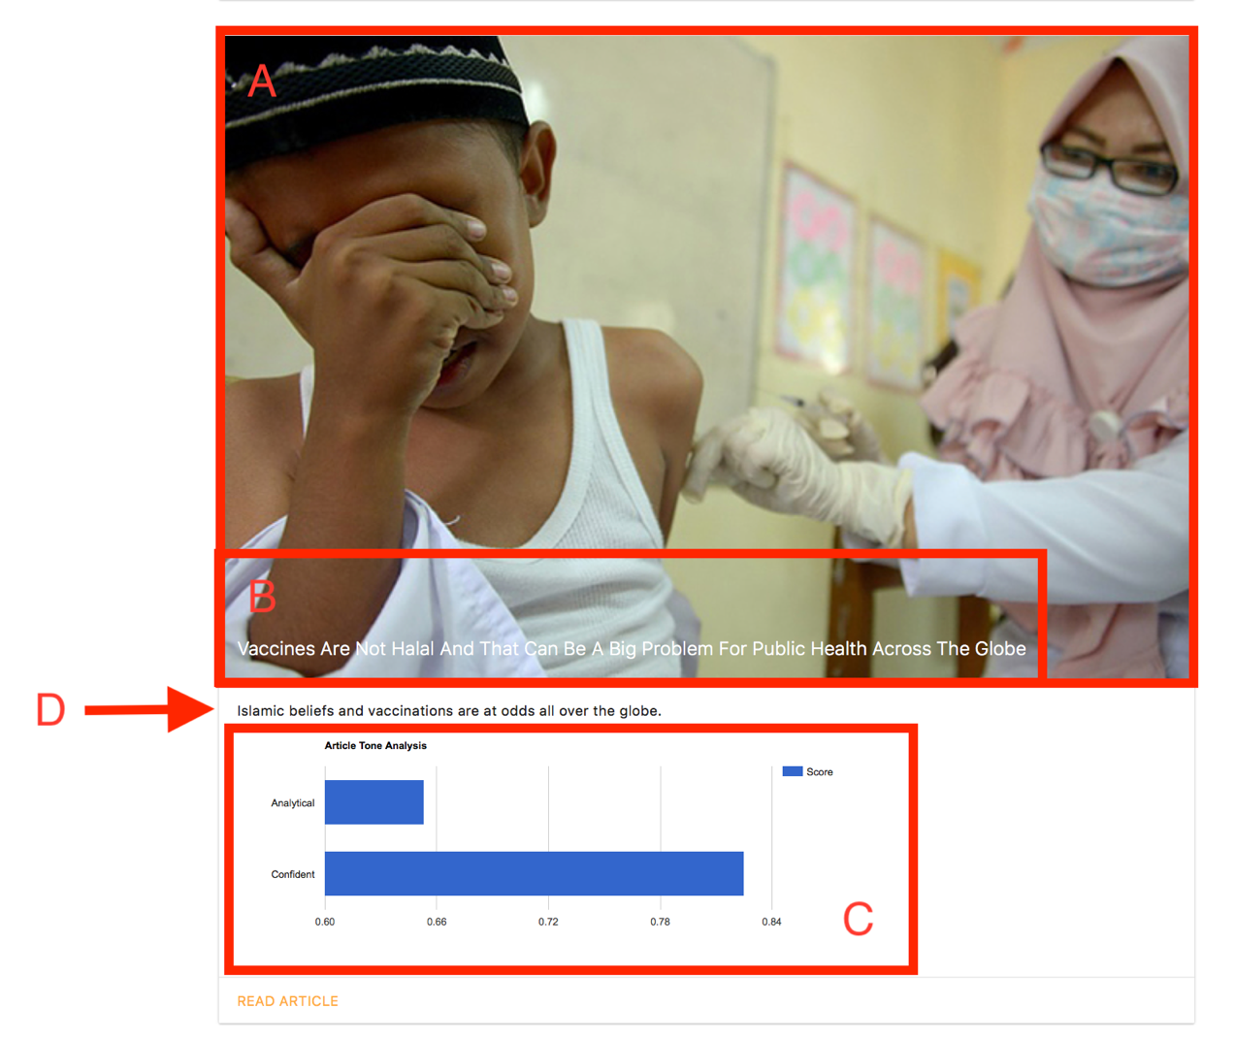

06: Link to article redirects correctly

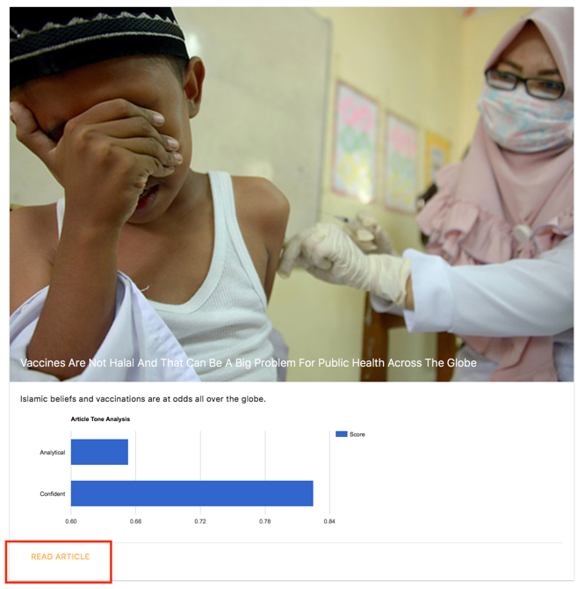





07: Display error, application continues

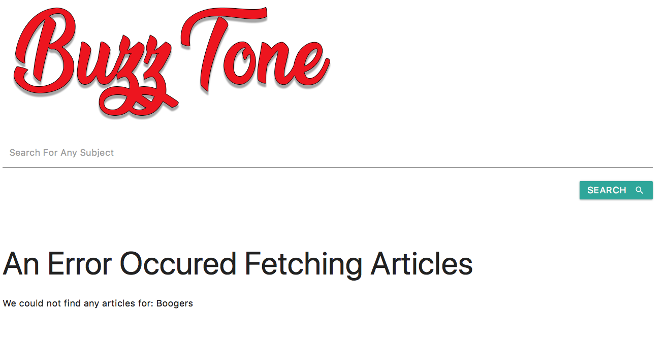

08: Display error, application continues